Grandpa Saguaro
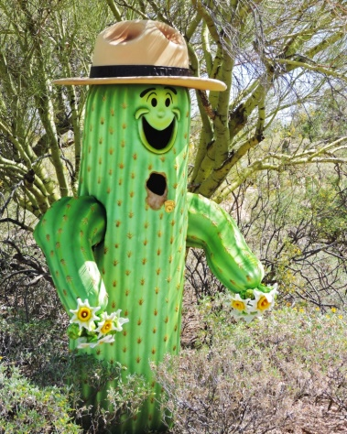
Anna is a curious little saguaro who wants to know how old her grandpa is. However, Grandpa Saguaro does not want to tell her his age directly. Instead he gives her some information to piece together for her to use to find out his age.

As far as Grandpa can remember he was between 25 to 30 feet tall. Grandpa Saguaro suggests that Anna uses the constant 8 in her expression. As a final clue, Grandpa Saguaro told Anna to use his favorite number 3 as a coefficient. After much thinking, Anna came up with the expression below,

3x + 8 = y
where y equals age in years and x equals height

When asked, Grandpa Saguaro told Anna that the expression was right.

If x is between 25 to 30, how old is Grandpa Saguaro?
Plug in the possible x’s in the expression, and solve for each.

Grandpa Saguaro gave Anna another clue. The correct x value is the solution to the following expression,
5z + (SQRT25) + 8 where z is his favorite number.

How old is Grandpa Saguaro?
Refer to the Saguaro Height-to-Age Table to check your answer.

Finally, rearrange the expression so that Anna can find the height of Grandpa Saguaro given his age.

